DIS-PAC-POLY-Marquesas Adze from Hawaii-RARE-final

# Marquesan style basalt Trilateral (three-sided) adze from upland Kohala on the Island of Hawai’i. This adze style is extremely rare in Hawai’i as the traditional (and later) omnipresent Hawai’ian adze style was quadrangular. It possibly demonstrates that the Marquesan Trilateral adze style was transported to Hawai’i very early (ca. 650-750 AD/CE) by Marquesans, who were one of the first founding groups.

# Other Trilateral (three sided) style adzes from the Marquesas

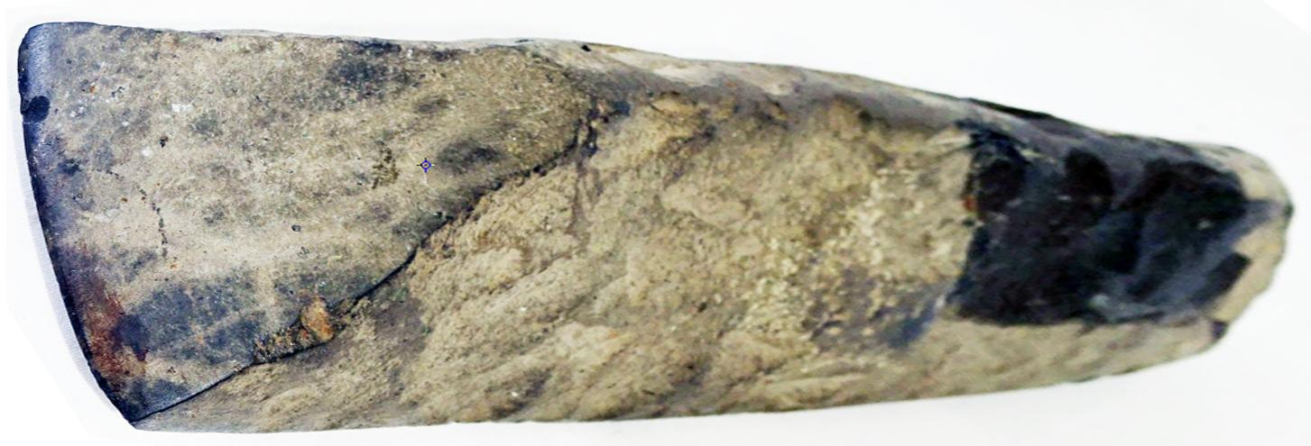

Marquesas, Nuku Hiva, trilateral basalt adze, from an old collection with accession number painted over (?).10 in x 2.75 in.

EX collector in Honolulu, then André Harnisch, 2016, Hawai’i, US $1,289.00. Photo: André Harnisch.

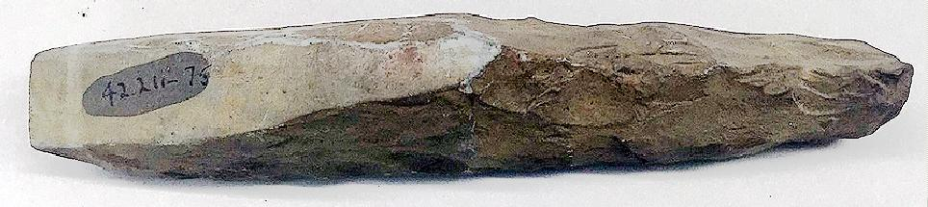

Marquesan trilateral basalt chisel, Brooklyn Museum 3 1/8 x 1 5/16 x 1 3/4 in. (8 x 3.3. x 4.5 cm), A. Augustus Healy Fund, 42.211-75. (Photo: Brooklyn Museum, CUR.42.211.75.jpg).